Lab 2 – EC2 Security Responsibilities

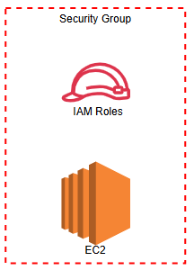

Task 1
- Launch Instance
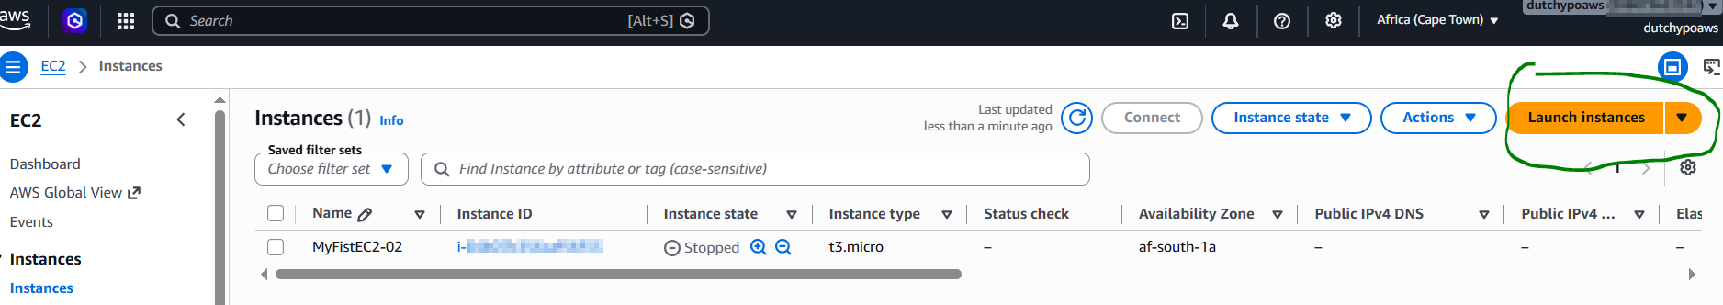

Task 2

- Security Group
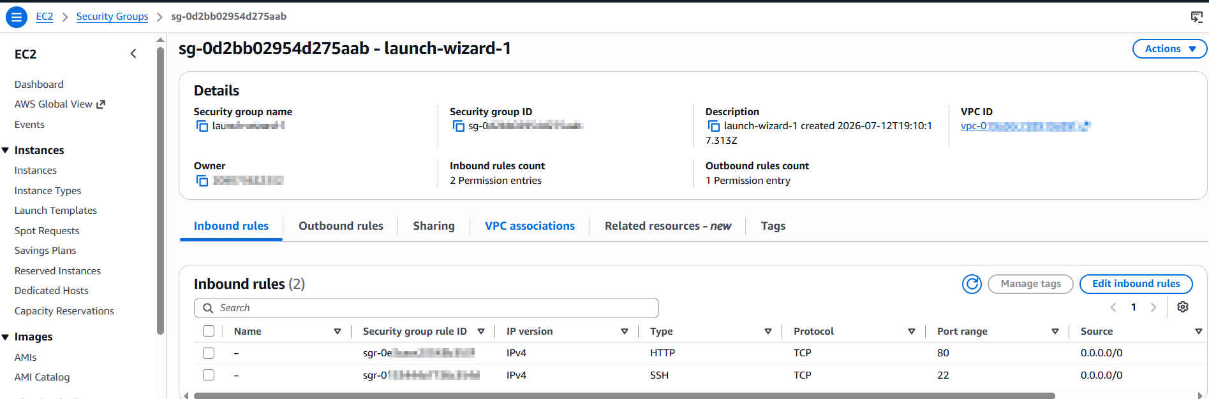

- Key Pair
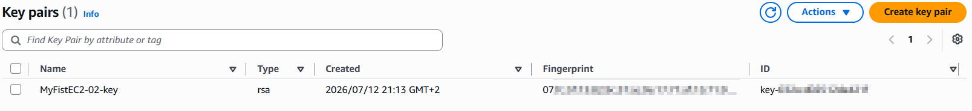
- IAM Role
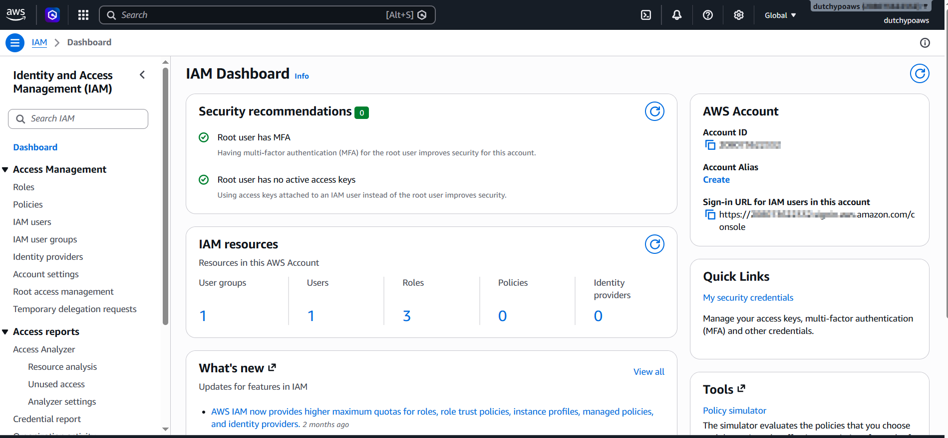

- Storage
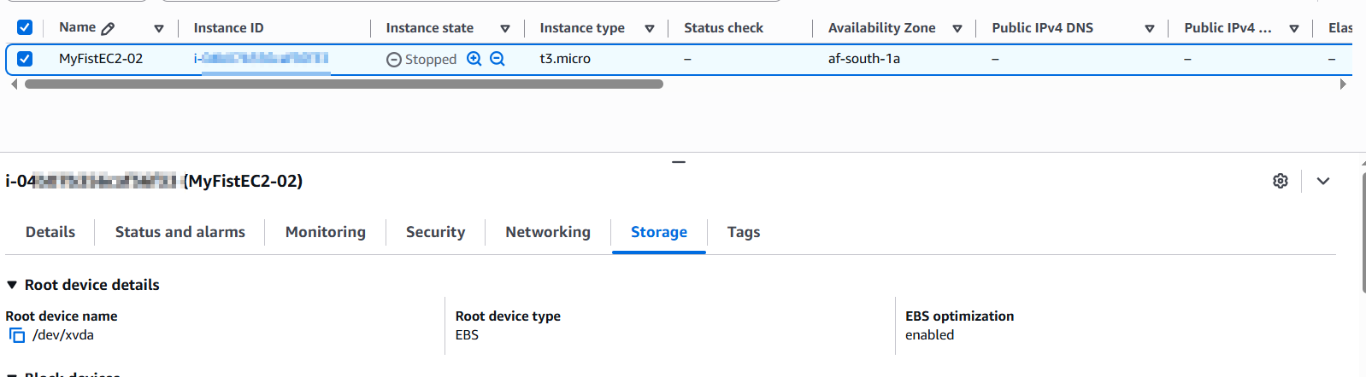

- Network
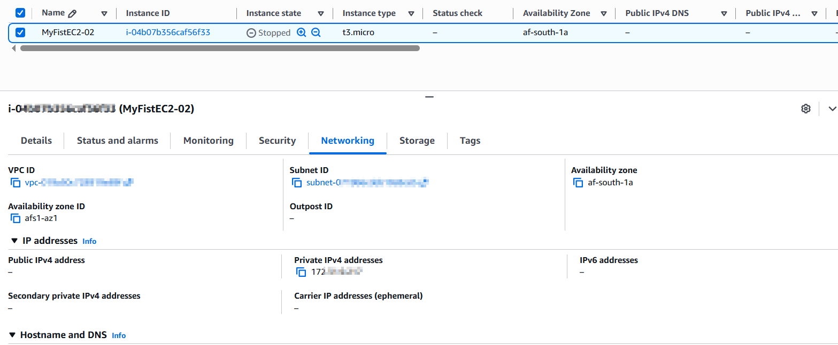

Task 3
RESPONSIBILITY | AWS | CUSTOMER
Installing Software
Updating the OS
Configuring the Firewall
Managing Application Security
Encrypting Sensitive Application Data

